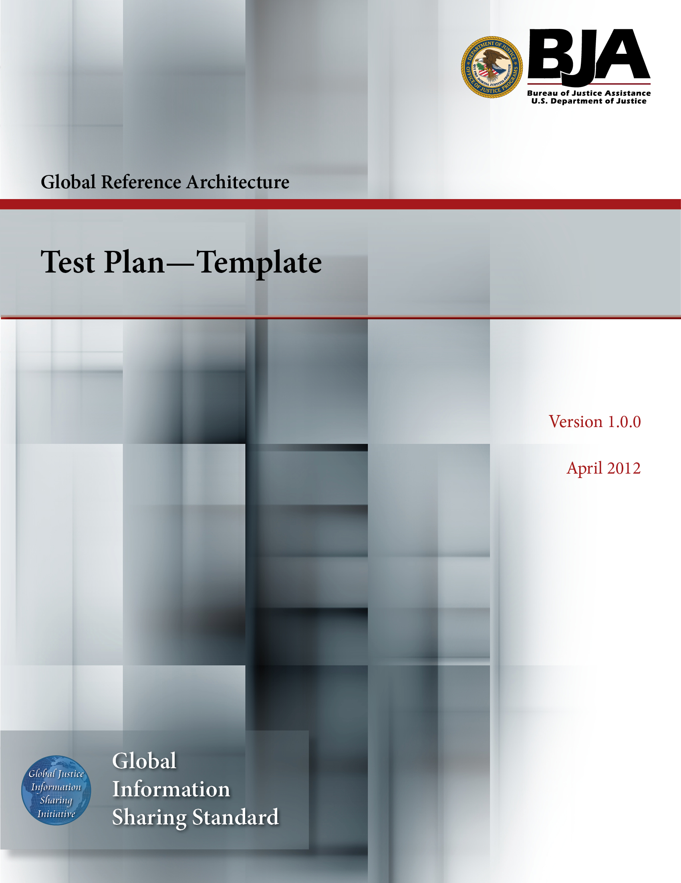
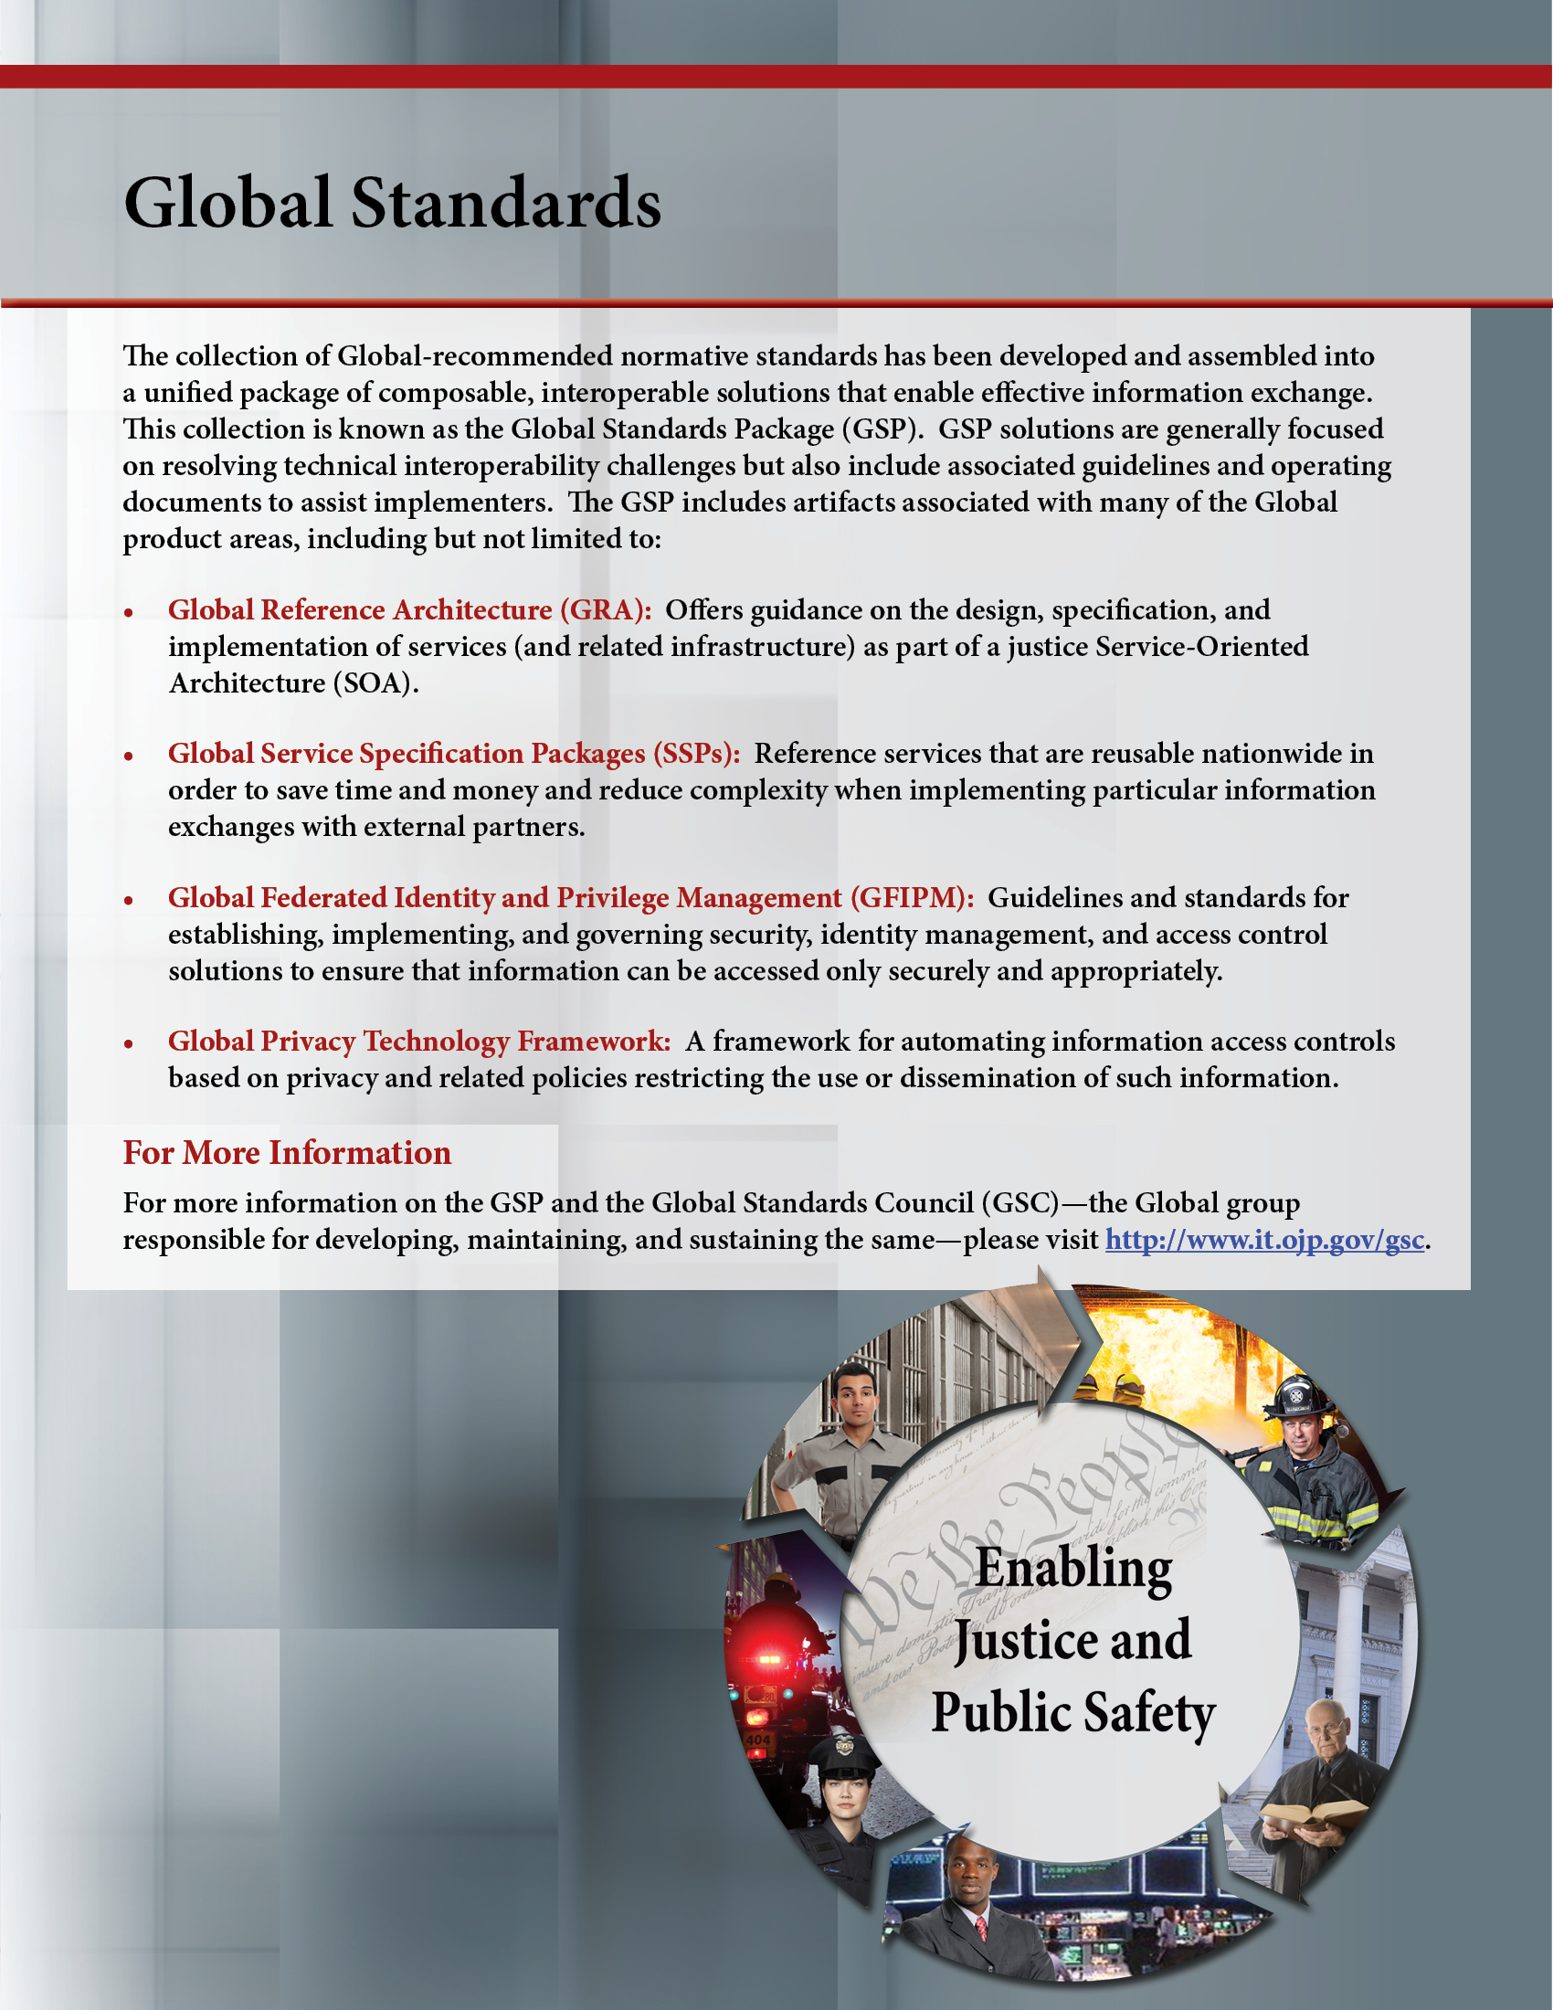

The Global Reference Architecture (GRA)

[Service Name] [Service Abbreviation] [Service Version]

Test Plan (Template)

Version 1.0.0

By [Name of Organization]

[Month Year]

Table of Contents

Document Conventions ii
1. Introduction 1
1.1 Purpose 1
1.2 Intended Audience 1
1.3 Definitions, Acronyms, and Abbreviations 1
1.4 References 2
1.5 Overview 2
2. Test Strategy 2
2.1 Test Objectives 2
2.2 Testing Types 3
2.3 Testing Tools 3
3. Target Test Items 3
4. Deliverables 3
4.1 Test Evaluation Summaries 3
4.2 Reporting on Test Coverage 3
4.3 Perceived Quality Reports 4
4.4 Incident Logs and Change Requests 4
4.5 Smoke Test Suite and Supporting Test Scripts 4
4.6 Additional Work Products 4
5. Environmental Needs 4
5.1 Test Environment Configurations 4
6. Responsibilities, Staffing, and Training Needs 4
6.1 People and Roles 4
6.2 Staffing and Training Needs 6
7. Test Plan Risks, Dependencies, Assumptions, and Constraints 7
Appendix A—References 9
Appendix B—Glossary 10
Appendix C—Document History 11

Document Conventions

[Note: The following template is provided for use with the Service Development Process. Text enclosed in square brackets and/or displayed in blue is included to provide guidance to the author and should be deleted before publishing the document.]

<Project Name> Test Plan

Introduction

Purpose

The purpose of the Test Plan is to:

- Provide a central artifact to govern the planning and control of the test effort. It defines the general approach that will be employed to test the software and to evaluate the results of that testing, and is the top-level plan that will be used by managers to govern and direct the detailed testing work.

- Provide visibility to stakeholders in the testing effort that adequate consideration has been given to various aspects of governing the testing effort and, where appropriate, have those stakeholders approve the plan.

This Test Plan also supports the following specific objectives:

- Identifies the items that should be targeted by the tests.
- Identifies the motivation for and ideas behind the test areas to be covered.
- Outlines the testing strategy and the approach that will be used.
- Identifies the required resources and provides an estimate of the test efforts.
- Lists the deliverable elements of the test project.

Intended Audience

[This section can be opted out depending on your project. Provide a brief description of the audience for whom you are writing the Test Plan. This helps readers of your document identify whether it is a document intended for their use and helps prevent the document from being used inappropriately.

Note: The document style and content usually alters in relation to the intended audience.

This section should only be about three to five paragraphs in length.]

Definitions, Acronyms, and Abbreviations

[This subsection provides the definitions of any terms, acronyms, and abbreviations required to properly interpret the Test Plan. Avoid listing items that are generally applicable to the project as a whole and that are already defined in the project’s Glossary. Include a reference to the project’s Glossary in the References section.]

References

[This subsection provides a list of the documents referenced elsewhere within the Test Plan. Identify each document by title, version (or report number if applicable), date, and publishing organization or original author. Avoid listing documents that are influential but not directly referenced. Specify the sources from which the “official versions” of the references can be obtained, such as Intranet UNC names or document reference codes. This information may be provided by reference to an appendix or to another document.]

Overview

[This subsection outlines what the rest of the Test Plan contains and gives an introduction to how the rest of the document is organized.]

Test Strategy

[The Test Strategy presents an overview of the recommended strategy for analyzing, designing, implementing, and executing the required tests. The Target Test Items identifies what items will be tested. This section describes the testing objectives, what types of tests will be conducted, and how these tests will be realized.

As you identify each aspect of the approach, you should update the appropriate sections with the test environment configuration and other resources that will be needed to implement each aspect.]

Test Objectives

[This section provides the objectives that need to be accomplished during testing. Below is a list of a few sample objectives:

- Find as many bugs as possible.
- Find important problems, assess perceived quality risks.
- Advise about perceived project risks.
- Certify to a standard.
- Verify a specification (requirements, designs, or claims).
- Advise about product quality, satisfy stakeholders.
- Advise about testing.
- Verify that product compiles and works properly.
- Verify that product adheres to requirements.
- Fulfill process mandates.
- And so forth.

Each objective provides a context to the test effort and affects the way in which testing should be approached.]

Testing Types

[This section lists the different types of testing that will be performed during the course of the project—such as functionality, usability, reliability, performance, and supportability⎯and if necessary, the levels of testing⎯for example, integration or system.]

Testing Tools

[This section lists the tools that will be used for testing purposes. For each tool, a brief description should be provided, stating the purpose and how the tool will be used.]

Target Test Items

The listing below identifies those test items⎯software, hardware, and supporting product elements⎯that have been identified as targets for testing. This list represents which items will be tested.

[Provide a high-level list of the major target test items. This list should include both items produced directly by the project development team and items that those products rely on; for example, basic processor hardware, peripheral devices, operating systems, third-party products or components, and so forth.]

Deliverables

[In this section, list the various artifacts that will be created by the test effort that are useful as deliverables to the various stakeholders of the test effort. Do not list all work products; list only those that give direct, tangible benefit to a stakeholder and those according to which you want the success of the test effort to be measured.

Note: This section should be customized depending on the various testing deliverables your project will be producing; thus, the sections should be changed to match your deliverables.]

Test Evaluation Summaries

[Provide a brief outline of both the form and content of the test evaluation summaries, and indicate how frequently they will be produced.]

Reporting on Test Coverage

[Provide a brief outline of both the form and content of the reports used to measure the extent of testing, and indicate how frequently they will be produced. Give an indication as to the method and tools used to record, measure, and report on the extent of testing.]

Perceived Quality Reports

[Provide a brief outline of both the form and content of the reports used to measure the perceived quality of the product, and indicate how frequently they will be produced. Give an indication about to the method and tools used to record, measure, and report on the perceived product quality. You might include some analysis of Incidents and Change Request over Test Coverage.]

Incident Logs and Change Requests

[Provide a brief outline of both the method and tools used to record, track, and manage test incidents, associated change requests, and their status.]

Smoke Test Suite and Supporting Test Scripts

[Provide a brief outline of the test assets that will be delivered to allow ongoing regression testing of subsequent product builds to help detect regressions in the product quality.]

Additional Work Products

[List any other products that will be produced during testing.]

Environmental Needs

Test Environment Configurations

The following Test Environment Configurations need to be provided and supported for this project.

Configuration Name | Description | Implemented in Physical Configuration

Responsibilities, Staffing, and Training Needs

[This section presents the required resources to address the test effort outlined in the Test Plan—the main responsibilities and the knowledge or skill sets required of those resources.]

People and Roles

This table shows the staffing assumptions for the test effort.
[Note: Add or delete items as appropriate. This list depends on the size of the team and the roles people within the team will take during the test effort.]

Human Resources
Role | Minimum Resources Recommended  (Number of  Full-Time Roles Allocated) | Specific Responsibilities or Comments
Test Manager |  | Provides management oversight.  Responsibilities include:  - Planning and logistics  - Agreeing on testing mission and objectives  - Identify motivators  - Acquire appropriate resources  - Present management reporting  - Advocate the interests of test  - Evaluate effectiveness of test effort
Test Analyst |  | Identifies and defines the specific tests to be conducted.  Responsibilities include:  - Identify test ideas  - Define test details  - Determine test results  - Document change requests  - Evaluate product quality
Test Designer |  | Defines the technical approach to the implementation of the test effort.  Responsibilities include:  - Define test approach  - Define test automation architecture  - Verify test techniques  - Define testability elements  - Structure test implementation
Tester |  | Implements and executes the tests.  Responsibilities include:  - Implement tests and test suites  - Execute test suites  - Log results  - Analyze and recover from test failures  - Document incidents
Test System Administrator |  | Ensures that test environment and assets are managed and maintained.  Responsibilities include:  - Administer test management system  - Install and support access to, and recovery of, test environment configurations and test labs
Database Administrator, Database Manager |  | Ensures that test data (database) environment and assets are managed and maintained.  Responsibilities include:  - Support the administration of test data and test beds (database)
Designer |  | Identifies and defines the operations, attributes, and associations of the test classes.  Responsibilities include:  - Defines the test classes required to support testability requirements as defined by the test team
Implementer |  | Implements and unit tests the test classes and test packages.  Responsibilities include:  - Creates the test components required to support testability requirements as defined by the designer

Staffing and Training Needs

This section outlines how to approach staffing and training the test roles for the project.

[The way to approach staffing and training will vary from project to project. If this section is part of a Test Plan, you should indicate at what points in the project lifecycle different skills and numbers of staff are needed.

Give thought to your training needs, and plan to schedule this based on a Just-In-Time (JIT) approach—there is often a temptation to attend training too far in advance of its usage when the test team has apparent slack. Doing this introduces the risk of the training being forgotten by the time it is needed.

Look for opportunities to combine the purchase of productivity tools with training on those tools, and arrange with the vendor to delay delivery of the training until just before you need it. If you have enough headcount, consider having training delivered in a customized manner for you, possibly at your own site.

The test team often requires the support and skills of other team members not directly part of the test team. Make sure you arrange in your plan for appropriate availability of system administrators, database administrators, and developers who are required to enable the test effort.]

Test Plan Risks, Dependencies, Assumptions, and Constraints

[List any risks that may affect the successful execution of this Test Plan, and identify mitigation and contingency strategies for each risk. Also indicate a relative ranking for both the likelihood of occurrence and the impact if the risk is realized.]

Risk | Mitigation Strategy | Contingency (Risk Is Realized)

[List any dependencies identified during the development of this Test Plan that may affect its successful execution if those dependencies are not honored. Typically, these dependencies relate to activities on the critical path that are prerequisites or post-requisites to one or more preceding (or subsequent) activities. You should consider responsibilities for which you are relying on other teams or staff members external to the test effort to complete, timing and dependencies of other planned tasks, and reliance that certain work products will be produced.]

Dependency Between | Potential Impact of Dependency | Owners

[List any assumptions made during the development of this Test Plan that may affect its successful execution if those assumptions are proven incorrect. Assumptions might relate to work you assume other teams are doing, expectations that certain aspects of the product or environment are stable, and so forth.]

Assumption to Be Proven | Impact of Assumption  Being Incorrect | Owners

[List any constraints placed on the test effort that have had a negative effect on the way in which this Test Plan has been approached.]

Constraint On | Impact Constraint Has  on Test Effort | Owners

Appendix A—References

[This section is used to list applicable references.]

[Reference name and description] | [Fully qualified link/path to the reference information]

Appendix B—Glossary

[This section is used to list glossary terms used in the document.]

[Glossary term or acronym] | [Glossary term or acronym description]

Appendix C—Document History

[This section is used to document the history of the service description document.]

Date | Version | Editor | Change
December 11, 2011 | 1.0.0 | James Dyche  Iveta Topalova | Final 1.0.0 revision
December 20, 2011 | 1.0.0 | David Gillespie | Initial edit of 1.0.0 revision
April 2012 | 1.0.0 | Global Standards Council (GSC) | Global Advisory Committee (GAC) approved



